Student worksheet

8.1 Earth’s gravity pulls objects to the centre of the Earth

Pages 144–145 and 210

Gravity

1 Write the definition of the following words:

a gravity

b gravitational field

c weight

d mass

e newton

Isaac Newton is pictured below on the day he first pondered the idea of gravity.

2 Using the diagram, explain why the apple fell to the ground.

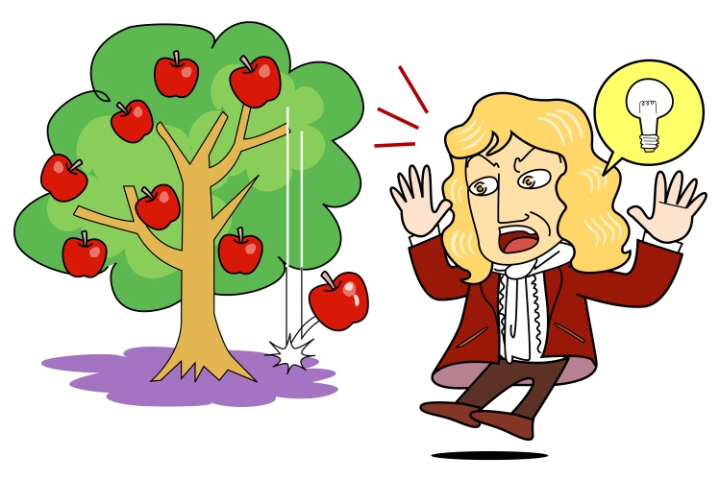

3 The apple has a mass of 200 grams. Using the diagram of the bricks as a guide, what would its weight be:

a on Earth? ____________________

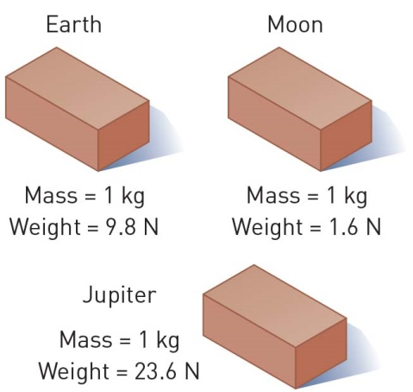b on the Moon? ____________________

c on Jupiter? ____________________

4 Assuming Newton’s mass was 60 kilograms, what was his weight:

a on Earth? ____________________

b on the Moon? ____________________

c on Jupiter? ____________________

5 In the space provided, draw a labelled diagram to explain why a tennis ball and a cricket ball would hit the ground at the same time when dropped from the same height.

|  |
| --- |
|  |

EXTEND YOUR UNDERSTANDING

6 What were another five discoveries made by Sir Isaac Newton?